Problem 4 – 3D Stars
You are given a rectangular cuboid of size W (width), H (height) and D (depth) consisting of W * H * D cubes, each colored in some color. Each color is denoted by a unique capital letter from the Latin alphabet: 'Y' is yellow, 'R' is red, 'B' is blue, 'G' green, etc. A 3D star is a figure of size 3 x 3 x 3 consisting of 7 cubes colored in the same color staying in the following configuration: one cube is the star center and 6 cubes are stuck at its 6 sides (see the figure below).
The figure below shows a sample cuboid consisting of 7 x 4 x 3 colored cubes (width = 7, height = 4, depth = 3) and how the 3D star figure looks like:
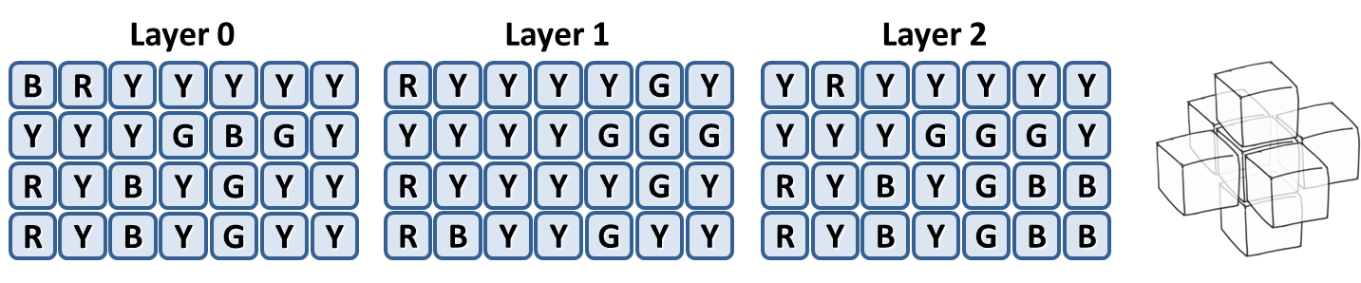
Your task is to write a program that finds how many 3D stars exist in the cuboid. At the cuboid above there are 4 stars: 3 yellow and 1 green. A cube is allowed to be shared between several stars.

Input
The input data should be read from the console. At the first line 3 integers W, H and D are given separated by a space. These numbers specify the width, height and depth of the cuboid. At the next H lines the colors of the cubes in the cuboid are given as D sequences of exactly W letters. Each sequence of W letters is separated from the next with a single space.
The input data will be correct and there is no need to check it explicitly.

Output
The output data should be printed on the console.
At the first line of the output print the total number of 3D stars in the cuboid. On the next few lines print the stars in the cuboid: color followed by a space and by amount found in the cuboid. Only colors with non-zero amount of stars should be listed. The colors should be listed in alphabetical order.

Constraints
- The numbers W, H and D are all integers in the range [3…150].
- The letter sequence in the input consists of capital Latin latters only
- Allowed work time for your program: 0.25 seconds.
- Allowed memory: 32 MB.

Examples
Input | Output |  | Input | Output
4 3 5  AAAA AAAA AAAA AAAA AAAA  AAAA AAAA AAAA AAAA AAAA  AAAA AAAA AAAA AAAA AAAA | 6  A 6 |  | 7 4 3  BRYYYYY RYYYYGY YRYYYYY  YYYGBGY YYYYGGG YYYGGGY  RYBYGYY RYYYYGY RYBYGBB  RYBYGYY RBYYGYY RYBYGBB | 4  G 1  Y 3

